**Description**

This document is created to

1. Create a self-signed SSL Certificate between web server and web client.
2. Deploy Test Central to production.

Requirement:

OS: Windows

Recommended: Windows7 Professional 64bit

1. **Create a self-signed SSL Certificate**

**Pre-require:**

Install OpenSSL from <http://indy.fulgan.com/SSL/>

**Steps to generate SSL Certificate**

Reference: <http://www.akadia.com/services/ssh_test_certificate.html>

**Step 1: Generate a Private Key**

**openssl genrsa -des3 -out server.key 1024**Generating RSA private key, 1024 bit long modulus  
.........................................................++++++  
........++++++  
e is 65537 (0x10001)  
Enter PEM pass phrase:  
Verifying password - Enter PEM pass phrase:

**Step 2: Generate a CSR (Certificate Signing Request)**

**openssl req -new -key server.key -out server.csr**Country Name (2 letter code) [GB]:**CH**  
State or Province Name (full name) [Berkshire]:**Bern**  
Locality Name (eg, city) [Newbury]:**Oberdiessbach**  
Organization Name (eg, company) [My Company Ltd]:**Akadia AG**  
Organizational Unit Name (eg, section) []:**Information Technology**  
Common Name (eg, your name or your server's hostname) []:**public.akadia.com**  
Email Address []:**martin dot zahn at akadia dot ch**  
Please enter the following 'extra' attributes  
to be sent with your certificate request  
A challenge password []:  
An optional company name []:

**Step 3: Remove Passphrase from Key**

**cp server.key server.key.org  
openssl rsa -in server.key.org -out server.key**

The newly created server.key file has no more passphrase in it.

-rw-r--r-- 1 root root 745 Jun 29 12:19 server.csr  
-rw-r--r-- 1 root root 891 Jun 29 13:22 server.key  
-rw-r--r-- 1 root root 963 Jun 29 13:22 server.key.org

**Step 4: Generating a Self-Signed Certificate**

To generate a temporary certificate which is good for 365 days, issue the following command:

**openssl x509 -req -days 365 -in server.csr -signkey server.key -out server.crt**  
Signature ok  
subject=/C=CH/ST=Bern/L=Oberdiessbach/O=Akadia AG/OU=Information  
Technology/CN=public.akadia.com/Email=martin dot zahn at akadia dot ch  
Getting Private key

1. **Deploy Test Central to production by thin**
2. Edit environment variable if exists: RAILS_ENV with value production, else create a new RAILS_ENV

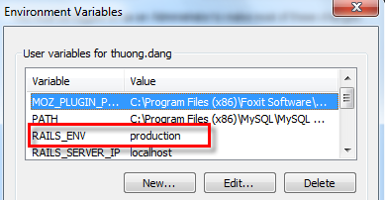

1. Update production database config in /config/database.yaml
2. /ssl folder contains ssl certificates. If you have new certificates, please replace them.
3. Start server: thin start --ssl -p 443
4. **Deploy Test Central to production by rack**

Update RAILS_ENV to production and then type cmd: rails s

1. **Notes**

**4.1 Cannot start server on a port, e.g. 443**

Error message:

*C:\Dev\sqaauto_testcentral>thin start --ssl -p 443*

*Using rack adapter*

*Thin web server (v1.6.3 codename Protein Powder)*

*Maximum connections set to 1024*

*Listening on 0.0.0.0:443, CTRL+C to stop*

*C:/Ruby200/lib/ruby/gems/2.0.0/gems/eventmachine-1.0.6/lib/eventmachine.rb:526:in `start_tcp_server': no acceptor (port is in use or requires root privileges) (RuntimeError)*

*<snip>…*

Solution:

Please make sure that the port 443 is available by using netstat statement.

Maybe Skype uses port 443. To check, please go to Skype option/Advance Settings/ Connection and observe:

cid:image002.png@01D04482.CC606110

**4.2 The compatibility of Ruby and gem libs, e.g. eventmachine lib**

Error message:

*C:\Dev\sqaauto_testcentral>thin start --ssl -p 3000*

*Using rack adapter*

*Thin web server (v1.6.3 codename Protein Powder)*

*Maximum connections set to 1024*

*Listening on 0.0.0.0:3000, CTRL+C to stop*

*terminate called after throwing an instance of 'std::runtime_error'*

*what(): Encryption not available on this event-machine*

*This application has requested the Runtime to terminate it in an unusual way.*

*Please contact the application's support team for more information.*

Solution: install corresponding Eventmachine version with Ruby platform

To check Ruby platform:

In CMD type: ruby –v

cid:image003.png@01D04469.0D3A6510

Eventmachine versions:

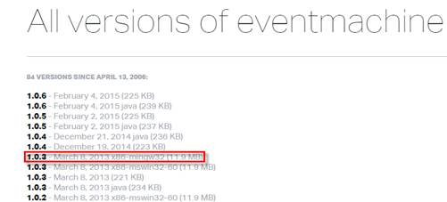

Please try to do the following steps to resolve this issue:

1. Uninstall current eventmachine

2. Get new source code

3. Bundle install

4. Make sure that eventmachine platform is the same ruby

cid:image007.png@01D0446B.9EF218C0